January 26, 2021

Good afternoon Families, Parents and Caregivers,

I am reaching out to inform you, that after the identification of recent cases in two of our schools, we made a request for an audit of our Health and Safety protocols, in order to ensure that we are continuing to meet the expected standard of cleaning, hygiene and disinfecting as set out by current Public Health mandates.

We had an Inspector come in from Interior Health to review our processes and practices. The feedback we received from this inspection is noted below, verbatim:

The audit review indicates that the school is adhering to the K-12 school setting requirements and has implemented strict cleaning and hygiene protocols.

We are pleased to have confirmed, and share that confirmation with you, that our Operations Department through its’ Custodial and Maintenance Staff are doing all that is possible to ensure that our schools are clean, hygienic and safe for all students and staff.

Our thanks go out to all our Staff for continuing to ensure that Health and Safety remain the priority for all our schools. Our appreciation also goes to you, for following the Public Health guidelines, completing the Daily Health Checks and ensuring that students attend school only when healthy to do so.

Respectfully,

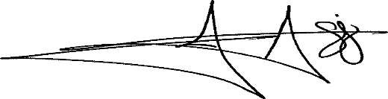

Jameel Aziz
Assistant Superintendent

